Full Title (Bold Calibri 16)

Presenting author, Co-authors (Calibri 14)
Organization, Address, City, Country (Calibri 12)
Contact@E-mail (Italic Calibri 12)

Abstract (Calibri 12)
Maximum one page is allowed.
Do not change the font sizes or line spacing.
Page settings A4: 21.0 cm x 29.7 cm. All margins are set to 1,2 cm.

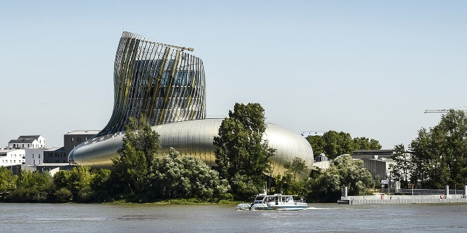

Figure 1: “Cité du Vin”, both a museum dedicated to the cultural heritage of wine
and a lively space with a range of gastronomic activities. (Italic Calibri 11)

REFERENCES
- Reference style : indicate references by number in square brackets in line with the text (Calibri 11).
Reference formatting : at your convenience.
- …
- …
- …

